DAT 702 Synthesis – Extended Proposal  
Jason Tinsley  
MRes in Digital Art and Technology  
Autumn 2021

Contents

Introduction 3

Context 5

Methodology 6

Summary of Contextual Repository 8

Documentation and analysis of Test Pieces 10

Plan of Work 13

Bibliography 15

Appendix 1 16

## Introduction

With this project, I intend to utilise LIDAR technology, 3D printing and interactive games technology to investigate how individuals’ perceptions of historical artefacts can be affected within a museum environment. Working closely with Penlee Museum in Cornwall, this project aims to improve my skills as a creative practitioner using an array of innovative design and visualisation technologies to inform and educate. The solutions found are also intended to address and accessibility issue and to give access to artifacts held in storage: leaving a lasting legacy, both digital and physical for future generations. The curators have asked for technological and creative solutions that increase engagement for all visitors irrespective of any physical limitations that they may have. The opportunity to use photo-realistic texturing and animation techniques has potential to bring to life the past in a way that is rarely seen in an educational environment.  
 There are several potential solutions that would serve both requirements. Fortunately, this is not an unknown area of research. For example, the University of Quebec has recently published their findings from a two-year study that utilised several *Assassin's Creed* (Ubisoft, 2009) titles to teach contextual history to a range of undergraduate students. (Karsenti, 2020)   
 The use of LIDAR technology is similarly not new in the preservation of archaeological finds. Significant use of scanning technology has been used at Palmyra in Syria (NewPalmyra, 2020) and more recently Historic England (Historic England, 2018) have been using 3D laser scanning to provide a digital record of important locations and artefacts.  
Finally, 3D printing, although a relatively new technology has already found application within archaeology itself, although less so in museum environments.  
This project intends to integrate these technologies in order to provide an immersive and educational experience that benefits both disabled and able bodied users alike; changing their perception and understanding of the past and its’ inhabitants.

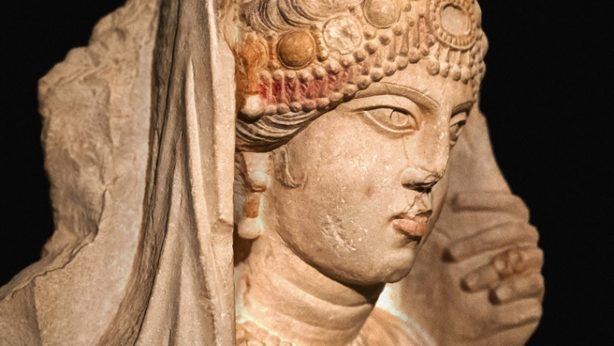

Figure 1. Beauty of Palmyra (Mackay, 2019)

## Context

I find museums and exhibitions to be a relatively passive experience; The glass stands between us and the object, we are denied the opportunity to hold objects in our hands; isolating us from the legacy of the people that created and used them. The opportunity to remove this distance is compelling and could literally make historical artifacts living things once more.  
 With the use of LIDAR scanning, photo realistic object creation has become a reality. it allows creative individuals to design and develop substantial interactive experiences that have a level of a verisimilitude Unknown only five years ago. This level of authenticity goes far beyond the games arena and has recently found a foothold in the Media and Visual Effects industries. Lucasfilm has recently begun the use of The Volume, (Coldewey, 2020) a piece of technology developed by Epic Games and Nvidia that allows photoreal environments to be simulated in real time with accurate lighting and without the need for a substantial green screen or other projection apparatus. This level of realism has taken the industry by storm and has shown once and for all that Games technology has developed to a point where it is difficult to distinguish the imaginary from the real.  
 It is this verisimilitude that I wish to utilise by using the newest incarnation of the Unreal Engine technology, which has a dynamic lighting and modelling system that lends itself ideally to the simulation of real world environments, objects and characters. I believe that it can be effective in changing people’s perceptions and experience of the world around them.  
I am working with Penlee museum in Cornwall to test my theory that digital technology can indeed change people's perceptions of objects and places from a historical context.  
 The museum has a deployment date in mind, so the work that needs to fit within a practical time frame. 65 hours has been allocated for me to research and test the practicality of my approaches and allowing me to refine the process and its application. Early prototypes have already been produced and presented to both the course leaders and the museum curators, with a distinct direction and focus being identified. Additional meetings will be arranged to set up milestones answer ensure both the museum and I are working in concert.

## Methodology

One of the most important aspects of this project is that I want the gap between the artifact and the person to disappear, For the past to become a real thing to them: not Distant, but Current. The experience should be an active one, developing a richer texture and a deeper appreciation of the history of the objects and the time in which they were created; effectively restoring the link between the Index and the Icon. (Peirce, 1955)

The initial phase of the project will be experimental, which will incorporate use of laser-scanning, Photo-realistic rendering, 3D object creation and interactive environmental integration.  
This will be evaluated in close conjunction with the museum curators to ensure that the quality of the 3D prints are of an acceptable standard and are robust enough to be handled by the public. The interactive environment will be tested by peers and will go through an iterative design process, With feedback from industry professionals familiar with photo realistic interactive imagery and environments as well as individuals who do not need to understand the technological aspects, but whether they feel that the experience is richer and more engaging than would be expected in a museum environment.  
 Two types of targeted questionnaires will be used evaluate their effectiveness:  
 The first will deal with the technical, creative and practical applications, and will be aimed at individuals familiar with the techniques and approaches required to be effective as a piece of interactive visualisation and fabrication. The second will be aimed on a more abstract level, with questions asking if the objects and interactive displays helped change their perception and whether they felt this had developed a deeper and more nuanced experience of history.

This feedback will assist in identifying new areas of research and avenues of investigation in order to produce an improved product and methods of creation.

Regular meetings with the museum will also provide essential critical feedback and provide focus on the direction of the project as a whole, with regular self-reflection and evaluation being conducted as a matter of course.

Summary of Contextual Repository   
I initially engaged with The *World of Perception* (Merleau-Ponty, 2004) to define what perception was. Merleau-Ponty’s work is highly accessible, and he breaks the world perception down into several sections, such as Science, Space and Sensory Objects. The penultimate section considers the perception of Art. Throughout the book, he makes a point that it is impossible to separate things from their way of appearing. However, he also states that no detail is insignificant and that in order to create meaning, it requires do we engage all our senses and our memories to construct the object in our mind. This is in stark contrast to the work of Loomis and Lederman (1986) who espouse a much more psychological and procedural approach. They investigate perception as separate senses and as judgements driven and mediated by temporal and physical cues. An area of particular interest was the phenomenology of touch, which states that touch is an active sense and is rarely, if ever passive and that the tactile response is often dominant: above that of vision.

This led me on to Lisa Wiegel’s work, *Perception in the digital age* (2010). In brief, she states that digital technologies operate out of sight, but their role is substantial. She agrees with Merleau-Ponty that the human body is considered fundamental to perception, but that Technology mediates between the subject and the world, and this has become normalised as our society becomes more technologically enmeshed. She states that there is a fragmentation of reality which reveals the fact that it is a construct: This has echoes of Baudrillard’s *Simulacra and Simulation* (1983) and Guy DuBord’s *The Society of the Spectacle* (1967). Finally, Wiegel states that we need to become aware of the way our perception is altered in a technologically saturated society and that we should not be overwhelmed by the ubiquity of the hardware we carry with us and experience on a daily basis.

Finally, I looked at the use of digital technology in Archaeology as I feel it was directly relevant to my area of study. Digital scanning technology and 3D printing are viewed warily by archaeologists despite the very real advantages that they have.  
*Visualizing Archaeologists: A Reflexive History of Visualization Practice in Archaeology* (Opgenhaffen, 2021) places the use digital tools in a historical context and ends with a discussion on the shared creative visual practice and its teaching role within archaeological knowledge production.  
It discusses archaeologists use digital technology to record data of excavations and artefacts as they are found but also that surprising reluctance to use 3D visualisations to show representations of these objects and places as they were in the past.  
Opgenhaffen somewhat lambasts archaeologists for this attitude, pointing out that many institutions already use replicas and casts in their displays the public, and have done so for centuries. He suggests that a more praxis-oriented and reflective approach to the use of visualisation and creative practice would help how archaeology responds to innovation and how it may adopt new visualisation technologies in the future.

## Documentation and analysis of Test Pieces

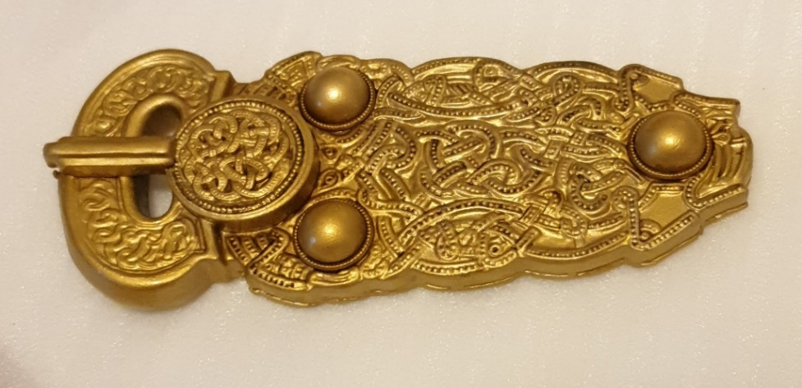

Figure . 3D print of a LIDAR file of the Sutton Hoo Great Buckle

In a series of meetings, Penlee Museum requested an informal proposal that showed potential solutions to their accessibility issues. As a result of research and experimentation, the curators have been offered four potential solutions: A pseudo hologram-based image of the artefacts, a Virtual Reality simulation, 3D printed objects, and an Unreal Engine based interactive environment that can be used with a conventional game controller.  
 As proof of concept, two prototypes were built: the first is a small tablet-based holographic projection, and the second was a painted 3D print of an Anglo Saxon belt buckle. Both were presented to the curators and the MRes course for appraisal and reaction during a planned workshop. Although I did not use a formal questionnaire to gather information, informal feedback from the participants was that although both approaches were impressive, they felt that the tactile feel of a physical object was preferable to that of a virtual display. This correlated with an informal experiment conducted with over 60 participants with ages ranging from 16 to 57. Without exception, these individuals expressed a preference to the physical object over the virtual animation and display of the hologram, although one individual did expand on their appreciation of the insubstantial nature of the hologram; this is DuBord’s theory of the image replacing reality made manifest.  
In the following meeting, the museum curators expressed preference for 3D printed objects and the Unreal Engine based environment, due to the amount of space and financial investment that the hologram and VR based solutions will entail.

Physical artifacts will be scanned on-site using handheld LIDAR unit, then converted into a format compatible for both integration into Unreal Engine 5, and as an STL file appropriate for 3D printing.  
The hologram prototype, although an effective demonstration of the technology, has issues that it requires a substantial amount of room as it scales up to a usable size. Unfortunately, as with a conventional wall display, the experience remains relatively passive, with visitors only able to view the object and not interact with it. This does not mean that this approach should be entirely discounted, but it may not be practical for areas with restricted space or viewing angles.

Figures 3, 4, and 5 are examples of experimentation using LIDAR scanned objects and integrating them into Unreal Engine 4. My methodology was to give myself a highly restricted time limit (10 minutes): forcing me to use pre-scanned digital assets that are publicly available. Each of the scenes is fully interactive, and it is easy to move the camera to different viewpoints using a conventional mouse and keyboard. The aim of this experiment was to examine the possibility of photo realistic environments within a game engine with reasonable resource use. The success of This process proves that photorealism can be achieved in a game engine: successfully utilising assets from real world sources, as will be the case with the scans of the artifacts from the museum.  
Although Giralt was speaking about the realism of VFX in film, his argument that there is a dialogue between two worlds of reality: the ‘fundamental’, objective reality and the ‘complimentary’, subjective reality (Giralt, 2017) is relevant here. All the assets are used for this experiment exist in the real world. There is a causal link, in much the same way that Pierce and Saussure stated that there is a causal link between the signifier and signified, the photograph and the subject.

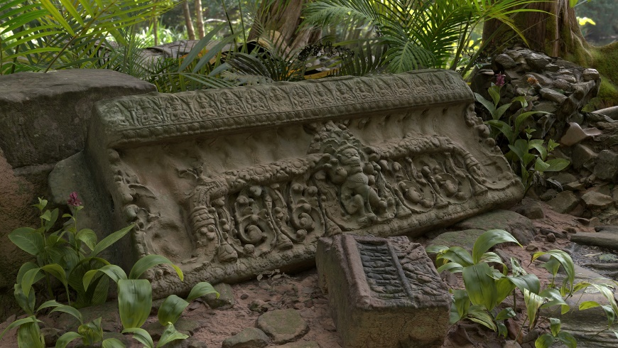

Figure 4 Lost to Time (Tinsley, 2021)

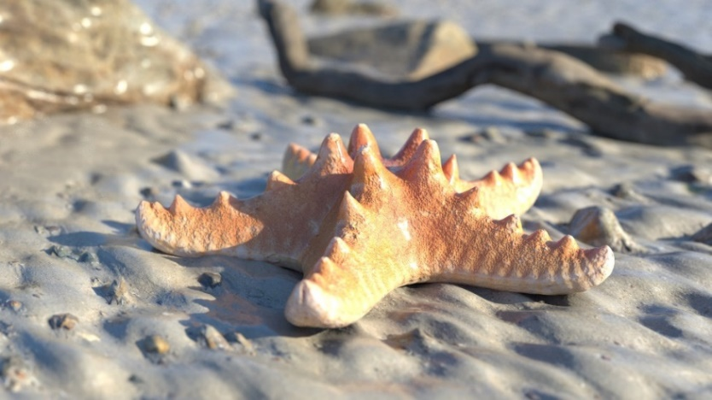

Figure 3. Low Tide (Tinsley, 2021)

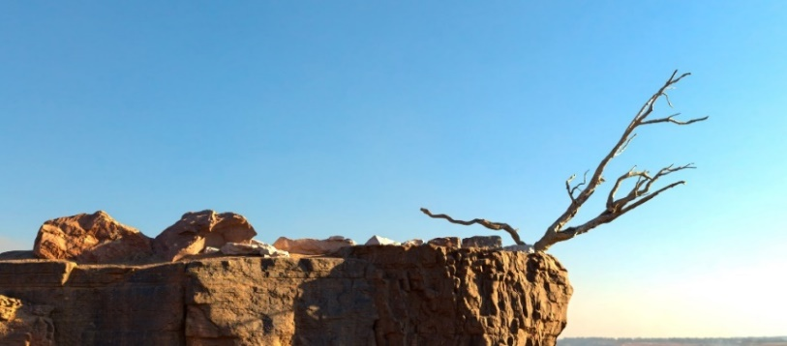

Figure 5. Desiccated (TInsley, 2021)

## Plan of Work

Summary  
My aim for this project is to explore avenues both technical and creative the satisfy an existing need from an external client and for me to expand and improve on my own creative and technical skills.  
This will by necessity, be driven by the need to learn new technical processes and develop new approaches to manipulating digital models and fabrication. However, creativity is still at the core of the product that will be created. although the objects are real, there is a level of artistic interpretation that will be needed to engage and enhance the perception of the people who will experience them.  
The opportunity to satisfy both the needs of Penlee museum and the chance to develop my skills, and the exploration and knowledge it will engender, is exciting and I look forward to the challenges ahead.

# Bibliography

Baudrillard, J., 1983. *Simulacra and Simulation.* Paris: Semiotext(e).

Coldewey, D., 2020. *How ‘The Mandalorian’ and ILM invisibly reinvented film and TV production.* [Online]   
Available at: https://techcrunch.com/2020/02/20/how-the-mandalorian-and-ilm-invisibly-reinvented-film-and-tv-production/  
[Accessed 9 October 2021].

Cooper, C., 2019. You Can Handle It: 3D Printing for Museums. *Advances in Archaeological Practice,* 7(4), pp. 443-447.

DuBord, G., 1967. *The Society of the Spectacle.* Paris: Black & Red.

Giralt, G., 2017. The Interchangeability of VFX and Live Action and Its Implications for Realism. *Journal of Film and Video,* 69(1), pp. 3-17.

Goethe, J. W. v., 2017. In: *Die Leiden des jungen Werther.* s.l.:Clap Publishing LLC, p. 51.

Historic England, 2018. *3D Laser Scanning for Heritage: Advice and Guidance on the Use,* Swindon: Historic England.

Karsenti, T. P. S., 2020. Teaching history with the video game Assassin’s Creed: effective teaching practices and reported learning. *Review of science, mathematics & ICT Education,* 14(1), pp. 27-45.

Knochel, A. D. W.-H. H. P. A., 2018. Touching to See: Tactile Learning, Assistive Technologies, and 3-D Printing. *Art Education,* 71(3), pp. 7-13.

Loomis, J. & Lederman, S., 1986. Tactual perception. *Handbook of perception and human performance,* Volume 2, pp. 1-41.

Mackay, G., 2019. *Beauty of Palmyra.* [Art] (Carlsberg Glyptotek).

Merleau-Ponty, M., 2004. Exploring the World of Perception: Sensory Objects. In: *The World of Perception.* London & New York: Routledge, pp. 59-66.

NewPalmyra, 2020. *#newpalmyra.* [Online]   
Available at: newpalmyra.org  
[Accessed 5 October 2021].

Opgenhaffen, L., 2021. Visualizing Archaeologists: A Reflexive History of Visualisation practice in Archeology. *Open Archeology,* Issue 7, pp. 353-377.

Peirce, C. S., 1955. *The Philosophical Writings of Peirce.* New York: Dover.

Tinsley, J., 2021. *3D print of the Sutton Hoo Great Buckle.* Launceston: Jason Tinsley.

TInsley, J., 2021. *Dessicated.* [Art].

Tinsley, J., 2021. *Lost to Time.* [Art].

Tinsley, J., 2021. *Low Tide.* [Art].

Ubisoft, 2009. *Assassin's Creed 2,* Montreal: Ubisoft Montreal.

Wiegel, L., 2010. *Perception in the digital age,* Utrecht: Utrecht University.

## **Appendix 1**

The following section gives more information regarding the contextual needs of the museum. Although important, the Museum’s requirements are not the core focus of this project, but rather is a scaffold within which I will work.  
  
 One of the core concerns of this project is to find a solution to an issue identified by staff members at Penlee Museum. The issue is that disabled access to the 1st floor of the museum is difficult or impossible without substantial modification to the structure of the building. As a result of recent discussions, an AR/VR representation of the artifacts and potentially immersive animation and environments was suggested as a potential solution.  
Disabled access to older buildings is a known and ongoing issue for many museums, art galleries and theatres across the country. This may be due to the age of the buildings, which may themselves be under highly restrictive rules or covenants due to their national (or international) importance as monuments themselves. The solution tabled by the curators of Penlee Museum is to use digital technology to allow disabled visitors to experience the artifacts held on the upper floor. This is highly innovative and would provide an enhanced visitor experience to not just disabled visitors, but to everyone.  
 The use of digital technologies in museums is becoming increasingly common, although there are stark divisions and how each institution chooses to use it (Cooper, 2019). Some believe it should be used to inform and educate, others prefer that it is used as a pure research tool. In this case, technology will be used to increase and improve the experience of all visitors irrespective of their physical ability. The decision to use an interactive environment and 3D prints also provides opportunities for outreach beyond the museum itself and impacting the local communities in a positive manner.  
  
Initially I intended to use my artistic practice as my methodology. However, I have been able to work closely with Penlee museum in Cornwall in a manner that allows me to satisfy both my needs and that of a client.  
Drawing on the work of Goethe (2017) and Maurice Merleau-Ponty (2004), I intend to use a multi-sensory approach that uses both vision and touch to make a persons’ perception of the object more substantive. As Merleau-Ponty states:

“Provided that we restore a particular quality to its place in human experience, the place which gives it a certain emotional meaning, we can begin to understand its relationship to other qualities which have nothing in common with it.” (Merleau-Ponty, 2004, p60)

It is this relationship that I intend to change from passive, to active using 3D prints and an interactive presentation of the objects as they would have looked in real-life.  
Some of the hardware this is required for this project is highly specialised and is available to me as a student at the University of Plymouth. Handheld LIDAR scanners are readily available and will be taken on-site to prevent damage to fragile artifacts. 3D printing will be performed the Fabrication Labs at the University, and in extremis, I have access to personal facilities to fabricate larger and more highly detailed prints if required.  
Ideally, 3D prints will be created in resin and infilled with a suitable material to increase the perceived weight of the object. Due to the nature of resins, they do not offer the same tactile feel as the original object, but they are more than rugged enough to be handled regularly. For larger objects, Fused Deposition Modelling (FDM) printers will be used to reduce the need for assembly. However, due to the FDM process, the objects will require more finishing than their resin counterparts.  
 In addition, an interactive display will be created for the museum using Unreal Engine 5, allowing visitors to interact with 3d models of the artifacts. Ideally, I would like to place these objects in an interactive environment, but I understand this may not be possible.  
Alongside my work with the museum, I intend to document this project using a production diary that shows the technical and creative process, test pieces, the practical outcomes as well as reflective self-evaluation and critical incident analysis. It is still my intent to improve myself as creative practitioner, so this analysis will include my efforts both technically and artistically.  
Potential avenues of data gathering will be targeted at the visitors to the museum featuring questions on the experience that they have had in handling physical 3D prints of objects and using an interactive digital environment should provide substantial amounts of data for analysis. In addition, with willing subjects, face to face interviews will also assist in the depth of information gathered. Although these views will be highly subjective, emerging trends should be able to be identified dependent on the quality and numbers of responses.